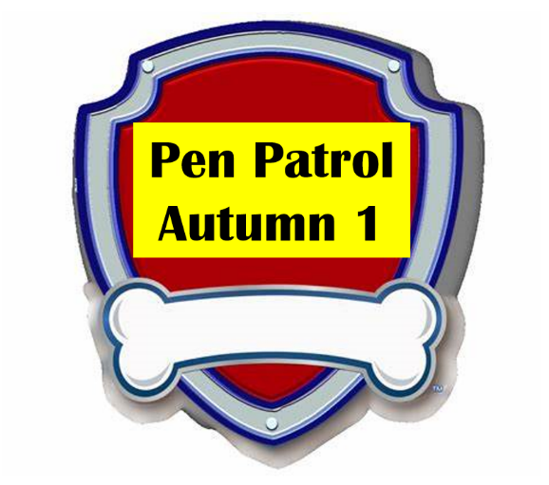

Forest Fields Primary School

Dear Parents
Every week we will be improving our speaking, listening and writing skills with our scheme called “Pen Patrol.” The children will really enjoy it as we have linked it to the Paw Patrol characters.
Each Monday we will be asking the children to bring an item into school to talk about. Please encourage them to practise talking about the item at home using the sentence starter. We will also be using ambitious vocabulary to help them improve their speaking skills.
We will start “Pen Patrol” next week. Please can the children wear a favourite t-shirt. Encourage them to practise saying “This is my favourite t-shirt because…”
Here is the plan for Autumn Term explain what you will need to send in each week.
 | Item to send in | Marshall’s sentence starter   | Chase’s vocabulary   | Sky’s sounds and Spellings  
12.9.22 | t-shirt | “This is my favourite t-shirt because…” | cotton  fabric  colourful  patterned | s a t p  big  red
19.9.22 | Photo of a special grown up | I love my … because…. | beautiful  caring  Kind | i n m d  dad  mum
26.9.22 | a photo of their treasured item | I treasure this because…. | precious  special  treasure | g o c k  is
3.10.22 | Memento or photo of their day out | I went to…. | Interesting  Exciting  memorable | ck e u r  I
10.10.22 | Bring something in from a nature walk (conker, leaf etc) | I found a …. on my Autumn walk | Leaves  Evergreen  deciduous | ff ll ss j  put* pull* full*  as

