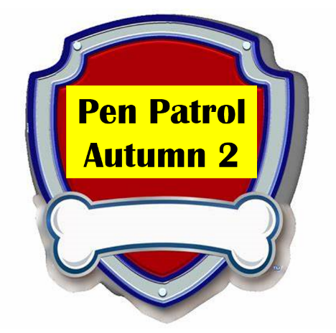
Forest Fields Primary School

Dear Parents
Every week we will be improving our speaking, listening and writing skills with our scheme called “Pen Patrol.” The children will really enjoy it as we have linked it to the Paw Patrol characters.
Each Monday we will be asking the children to bring an item into school to talk about. Please encourage them to practise talking about the item at home using the sentence starter. We will also be using ambitious vocabulary to help them improve their speaking skills.
 | Item to send in | Marshall’s sentence starter   | Chase’s vocabulary  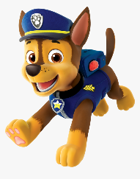 | Sky’s sounds and Spellings  
31.10.22 | Something to show what they did at half term | Last week I ….. | relaxing  playful  restful | j  Put  Is  the
7.11.22 | A fact about Diwali | Once there was… | Rama  Sita  Ravana  battle | V w x y  words with s /s/ added at the end (hats sits)  Ch  go no to into
14.11.22  Breakfast week | A picture of what they eat for breakfast | For breakfast I like to eat… | Delicious  Tasty  Ravenous  crunchy | sh th ng nk  she push* he of
21.11.22 | A collage of food they like for tea. | For tea I like to eat… | Greedy  Hungrily  ferocious | words with s /s/ added at the end (hats sits)  • words ending s /z/ (his) and with s /z/ added at the end (bags)  we me be
28.11.21 | Elf on the shelf!  The Elf will arrive and the children will keep a diary of his antics

