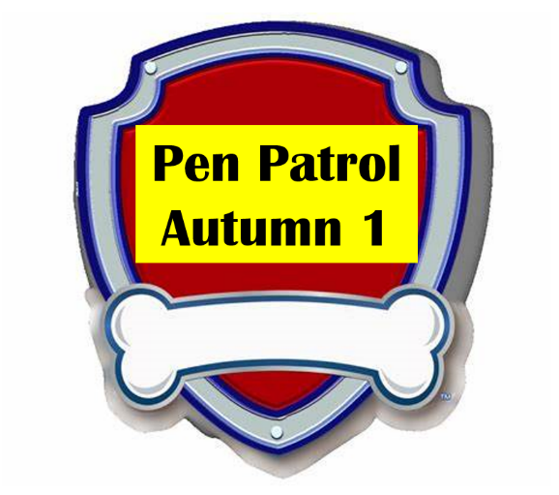
Spring 1

Forest Fields Primary School

Dear Parents
Every week we will be improving our speaking, listening and writing skills with our scheme called “Pen Patrol.” The children will really enjoy it as we have linked it to the Paw Patrol characters. Each Monday we will be asking the children to bring an item into school to talk about. Please encourage them to practise talking about the item at home using the sentence starter. We will also be using ambitious vocabulary to help them improve their speaking skills. If you would like to email any photos, we can show them on the screen at school. Heather.harper@forestfields.nottingham.sch.uk
Topic | Item to send in | Marshall’s sentence starter   | Chase’s vocabulary   | Sky’s sounds and Spellings  
5.1.23  Holiday News | Photo or item to talk about from their Christmas holiday | “Over the Christmas holiday I went..” | Celebrate  Festive  traditions | ai ee igh oa
9.1.23  Happy New Year | New Years Target | “This year I will …” | Resolution  Promise | Oo (zoo)  oo (book)  ar or  was you they
16.1.23  Chinese New Year | A fact about China | “In China there is …” | Continent  Traditions  Mandarin | ur ow oi ear  my by all
23.1.23  Burns Night | A fact from home about Scotland | “In Scotland there is …” | Country  United Kingdom  Lochs | air er  dd mm tt bb rr gg pp ff
30.1.23  Winter wonderland | Photo/drawing of a wintery scene | “Once upon a time, in a wintery wonderland…” | Icicles  Flurries  Fractals  snowflakes | Two syllable words
6.2.23  Valentines Day | Picture of someone they love | “Roses are red  Violets are blue…..” | Adore  Blessing  compliment | Two syllable words

