Forest Fields Primary & Nursery School | 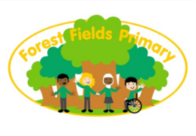
School Uniform & Bookbag Order Form

To order a school jumper, cardigan or bookbag please complete the order form below and return it with the correct payment in the envelope attached. The office will then process the order and deliver this to your child’s class, for your child to take home. Please send the correct money as we are unable to provide change. We cannot exchange uniforms or give refunds so please measure the size carefully.
Size Guide
Garments | To Fit Ages | 4/5yrs | 5/6yrs | 6/7yrs | 7/8yrs | 9/10yrs | 11/12yrs
Child Sweatshirts | To Fit Chest | 24″ 61cm | 26″ 66cm | 28″ 71cm | 30″ 76cm | 32″ 81cm | 34″ 86cm
Child Sweat Cardigans | To Fit Chest | 24″ 61cm | 26″ 66cm | 28″ 71cm | 30″ 76cm | 32″ 81cm | 34″ 86cm
 |  | Size 24 | Size 26 | Size 28 | Size 30 | Size 32 | Size 34

Adult Sweatshirts | To Fit Chest | 36” 92cm | 36/38” 92/97cm | 38/40” 97/102cm | 42/44” 107/112cm
Adult Sweat Cardigans | To Fit Chest | 36” 92cm | 36/38” 92/97cm | 38/40” 97/102cm | 42/44” 107/112cm
 |  | Size XS | Size S | Size M | Size L

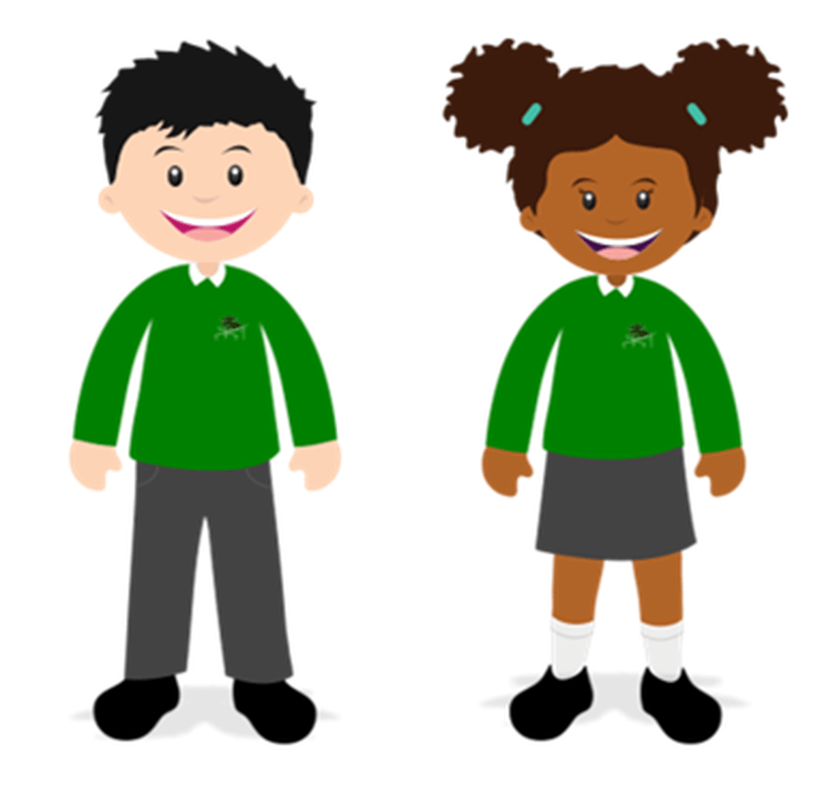
Measure the chest under the fullest part, placing the tape measure under the arms. Please measure accurately as no swaps or refunds can be made.
 | Size 24 | Size 26 | Size 28 | Size 30 | Size 32 | Size 34 | Price
Child Crew Neck Sweatshirt |  |  |  |  |  |  | £12.50
Cardigan |  |  |  |  |  |  | £12.50
Bookbag |  |  |  |  |  |  | £8
 | Size XS | Size S | Size M | Size L |  |  | Price
Adult Crew Neck Sweatshirt |  |  |  |  |  |  | £17
Adult Cardigan |  |  |  |  |  |  | £17
TOTAL:

Child’s Name…………………….………………………………. Class…………………………….……….

Parent Name……………..………………………..……… Mobile No………………………….……………
Please remember to send the correct payment. Thank you.

